Advanced Textures : Priming/Tiling a Photosource in Photoshop 6

Reload this article and prepare it for printing.
(removes banner ad and menubar and sets new width for page)
This article was last updated on Monday, April 22, 2002
Written by:
Anthony `Bean` Nichols
bean@planetunreal.com
Basic Tiling of Photosourced Textures in Photoshop 6
This tutorial is for those who are comfortable with Photoshop. This tutorial will showcase how to tile a photosource and prime it for importing into UnrealED.
First, open up Photoshop and open up your photo source in which you want to create the texture from. I`ll be using a picture of bark from a tree I took with my digital camera. Resize the picture (Image -> Image Size) to 512x512 so you have a high quality version to work with.
Next, we`ll get to the tiling. As you can probably tell, this picture will not tile on it`s own without a little guidance. So, go to Filter -> Other -> Offset.
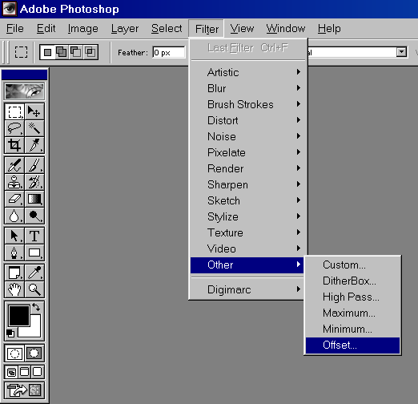
Next, enter the values 256 and 256 for Horizontal and Vertical and Wrap Around for Undefined Areas. Click ok, and you`ll have step one of the tiling finished.
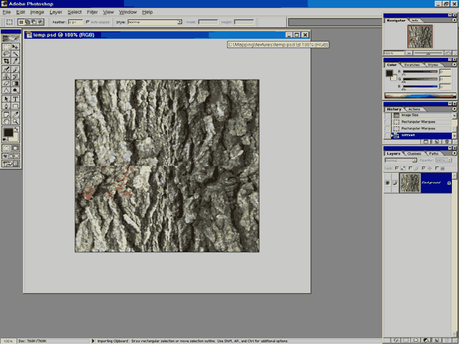
Step two consists of using the Clone Stamp tool to "tile" the middle seams. Make sure that your Stamp size is relatively large (65 soft/hard round is a pretty good size). Now, hold alt and left click an area of the picture that that is outside of you seams.That will "capture" that part of the picture so when you paint with it, it will "clone" what you define with the alt-left click. Now, start to fill in the seam, alt-left clicking different parts of your pictures to create a define similar seams. Experiment to find a good balance. Keep painting over the seams until none are left. What you painted may be a little blurry, so use the Sharpen Tool if necessary.
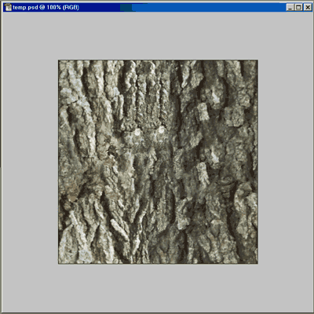
Output After Clone Stamping
Next, i`ll show you how I prepare the texture to be imported into UnrealEd. Go to Image -> Image Size and size it down to 256x256 (using Bicubic filtering). Now, we`ll change the brightness and contrast to make the texture seems more "rich". Go to Image -> Adjust -> Brightness/Contrast. I typically like to set my brightness to -15 and the contrat to +5 (depending on the texture). Don`t be afraid to experiment.
To finish, go to Image -> Mode -> Index Color. Convert it to 256 color and save as a .bmp/.pck file. To see how well it textures, I like to save it as a bitmap and tile it as my desktop background. If it tiles well, you`re set! If there are some problem, go back and fool around a bit. Practice makes perfect!

